If you want to build a CV builder that can compete with existing platforms, my recommendation is don't build just another AI CV generator. Build an AI-powered Career Success Platform.
Most CV builders focus on templates, formatting, and generating professional summaries. Your opportunity is to solve the bigger problems job seekers face:
- They don't know what recruiters are looking for.
- They apply for jobs but rarely receive interview calls.
- They don't know how to present their experience effectively.
- They struggle to tailor their CV for every job application.
- They don't know which skills they're missing for their dream role.
- They aren't prepared when they finally get an interview.
Your platform should help users move from "I need a CV" to "I'm ready to get hired."

1. The most interesting unique features to build
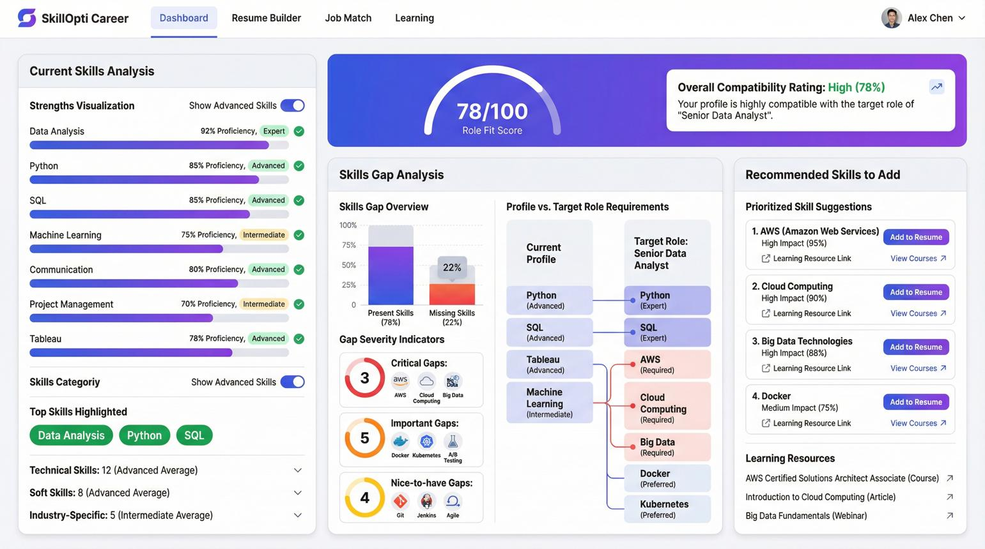

1. AI Job Match Simulator
Top priority
Users paste a job description or a job URL. Your platform analyzes their CV against that specific role and explains what matches, what is missing, and what to improve.
Unique twist: Show a transparent match breakdown instead of just an arbitrary ATS score.
- Required skills matched and missing
- Relevant experience and qualifications
- Missing keywords and certifications
- Evidence from the user's actual CV
- Specific suggestions to improve their application
Problem solved: "Why am I not getting shortlisted?"
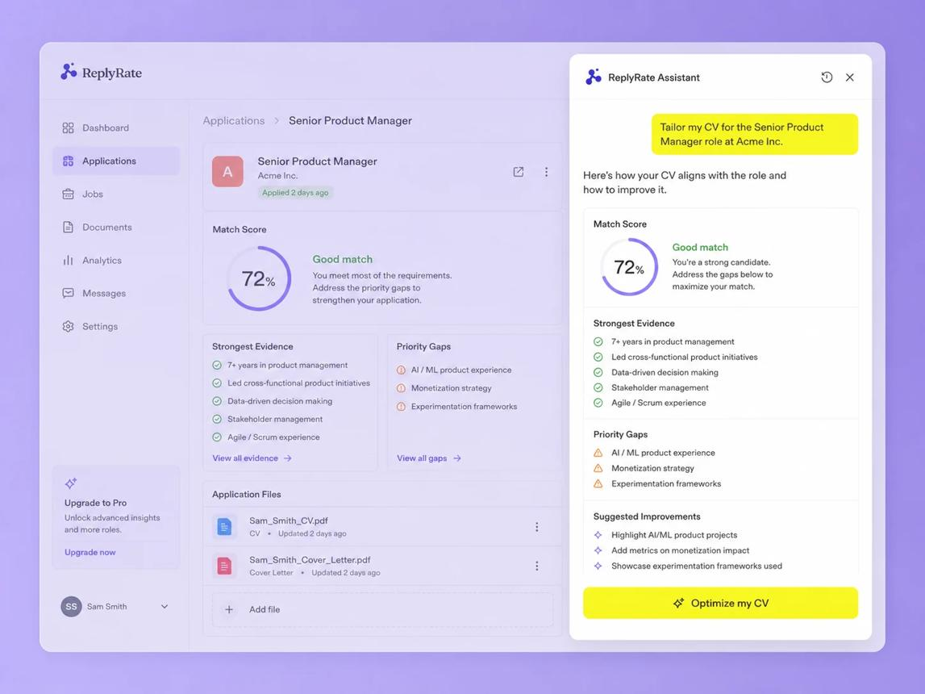

2. One-Click Job-Specific CV Generator
Users maintain one master career profile. For each job, the platform generates a tailored CV using relevant experience, skills, and achievements.
- Import a job description.
- Select the appropriate career profile.
- Tailor the summary, skills, and bullet points.
- Highlight relevant accomplishments.
- Export a recruiter-friendly PDF or DOCX.
Unique twist: Keep every claim grounded in the user's original profile. Never invent skills, qualifications, or work experience.
Problem solved: Rewriting the CV for every application takes too much time.
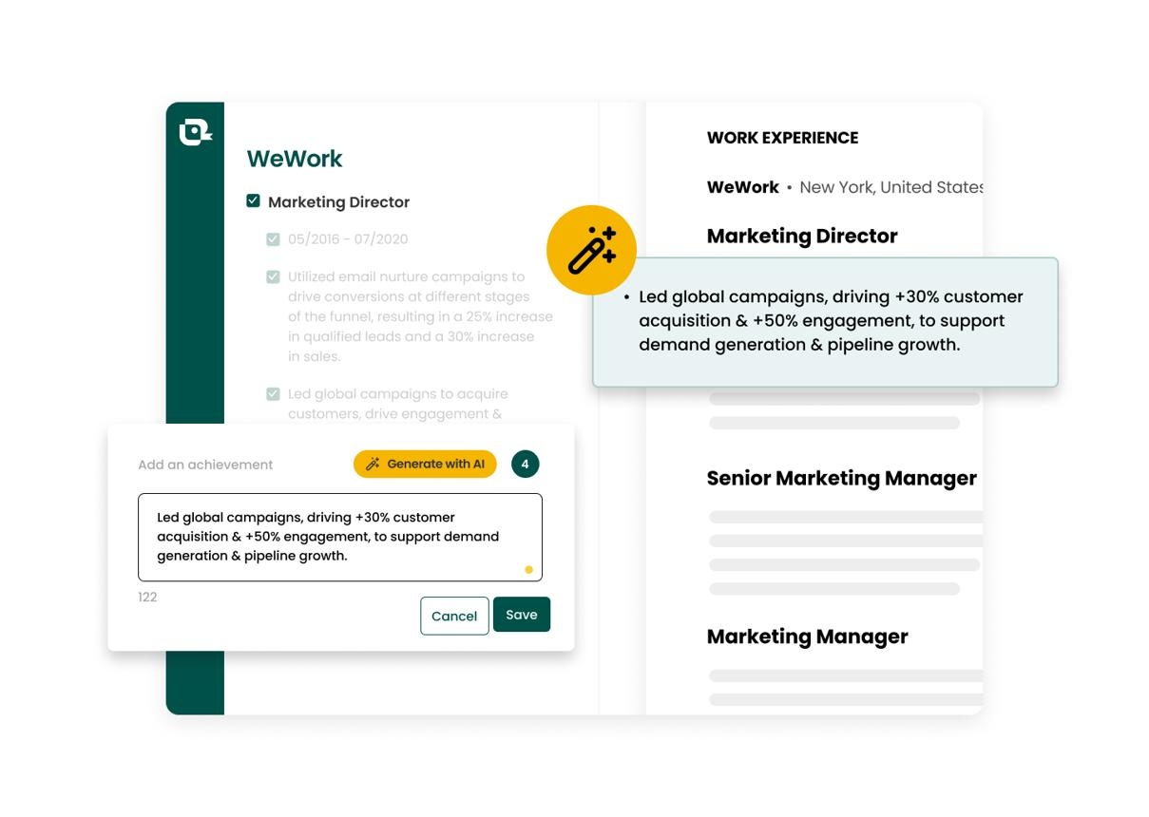

3. Achievement Discovery Engine
Many people have valuable experience but don't know how to communicate it professionally.
Your AI asks guided questions about their previous work and turns their answers into stronger CV achievements.
Example:
Before
"Responsible for managing the development team."
After — when supported by real evidence
"Led a 7-person development team, coordinated sprint delivery, and improved on-time release performance from 75% to 92%."
The platform asks follow-up questions about team size, budgets, delivery, revenue, time saved, and business impact. If the user doesn't know the numbers, it must not invent them.
Problem solved: Users struggle to demonstrate their actual value.

4. ATS & Recruiter Readiness Lab
Go beyond checking whether a CV contains keywords. Analyze whether it is readable, relevant, and easy to evaluate.
- PDF/DOCX text extraction check
- Headings and section structure
- Tables, columns, and formatting risks
- Job-description keyword coverage
- Missing dates or inconsistent job titles
- Readability and unnecessary content
Unique twist: Provide a visual preview of how the document's text is extracted, so users can spot parsing problems.
Be transparent that ATS systems differ; don't promise that any CV will pass every ATS.
Problem solved: Users don't understand why their carefully designed CV might be difficult for recruitment software to process.
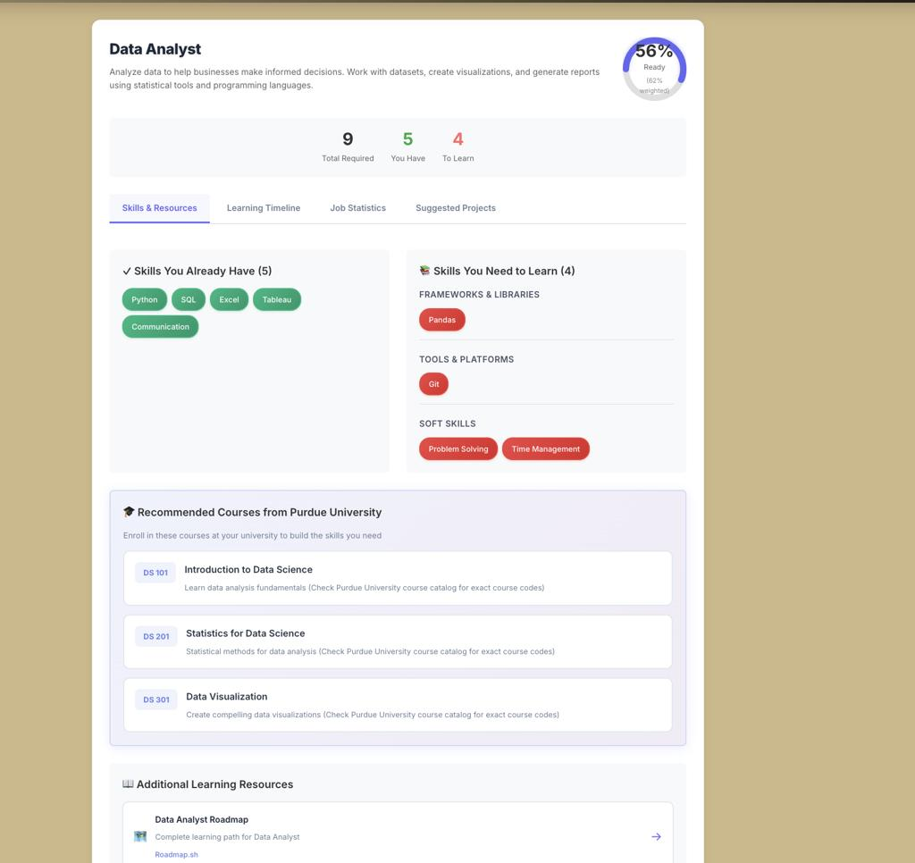

5. Career Gap & Growth Planner
Differentiator
A user selects a target job, such as Product Manager, Data Analyst, or Software Engineer. Your platform compares their current experience with the role's requirements.
It then creates a personalized roadmap:
- Skills they already have
- Skills they need to develop
- Projects that could demonstrate those skills
- Certifications worth considering
- Suggested portfolio improvements
- A practical 30-, 60-, or 90-day plan
Unique twist: Let users add evidence of completed projects and update their career profile as they progress.
Problem solved: People don't know what to learn next to qualify for better jobs.
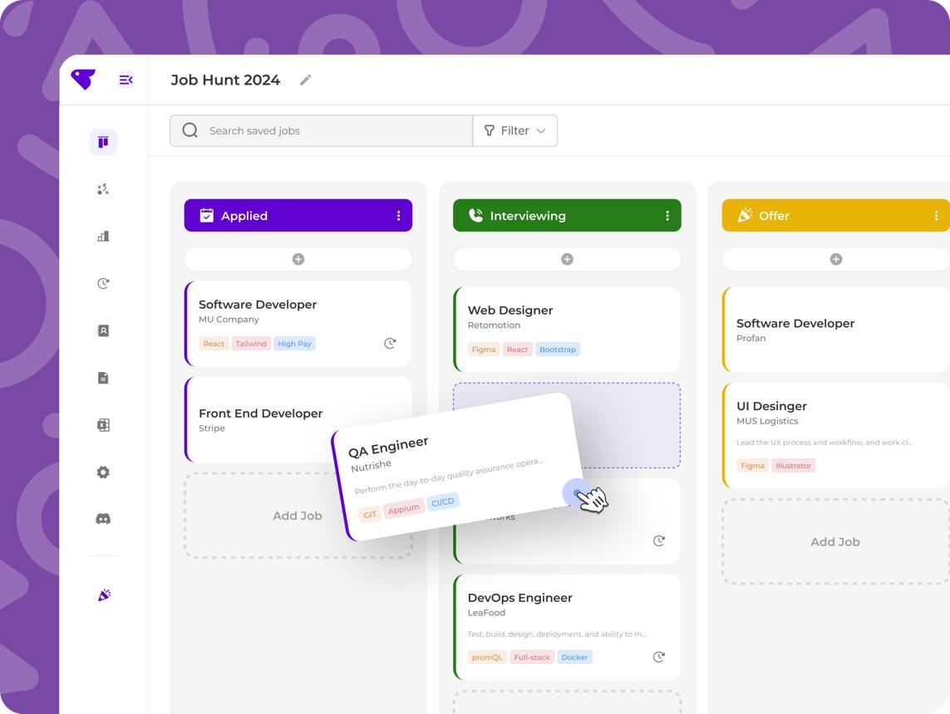

6. Smart Job Application CRM
Turn the CV builder into a place where users manage their entire job search.
- Save target jobs and application URLs
- Track Applied, Assessment, Interview, Offer, and Rejected
- Store the exact CV and cover letter used
- Set follow-up reminders
- Save recruiter contacts and interview notes
- Track interview rates by job type and CV version
Unique twist: After enough application data is available, show which CV versions and role types are getting better results, while explaining that small samples can be misleading.
Problem solved: Job seekers lose track of applications and repeat the same mistakes.

2. Five more features that could make your platform stand out
These are the features I'd explore to make the product more distinctive than a typical CV builder.
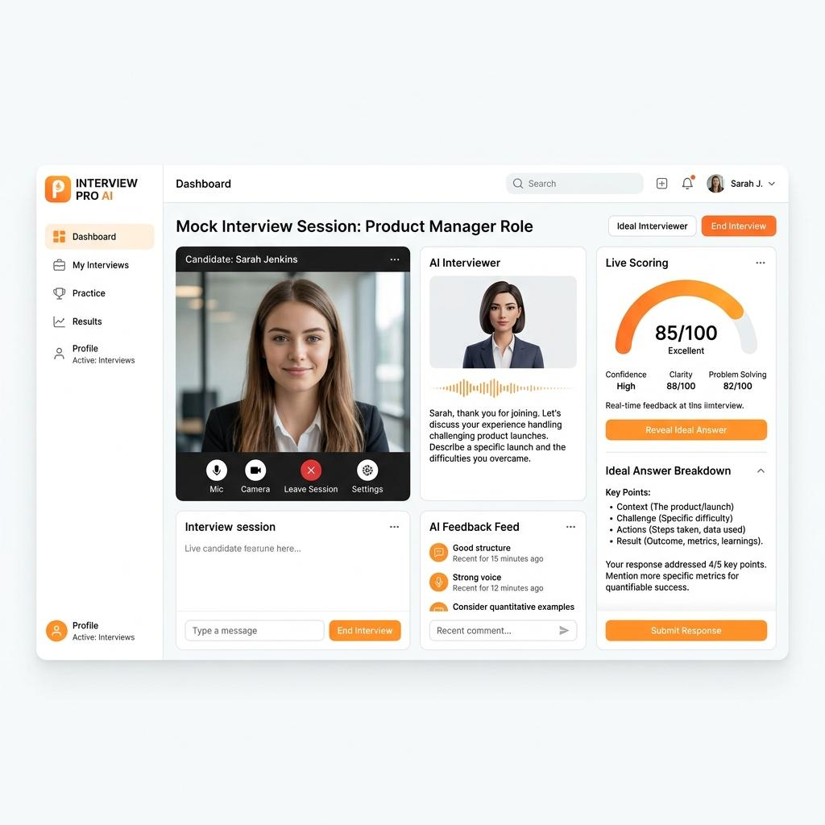
7. CV-to-Interview AI Coach
Generate interview questions from the user's actual CV and target job description. Let users practice by typing or speaking answers, then receive feedback on relevance, clarity, structure, and examples. Flag claims they may struggle to substantiate in an interview.
Why it's valuable: It connects CV creation with the next step in the hiring journey.
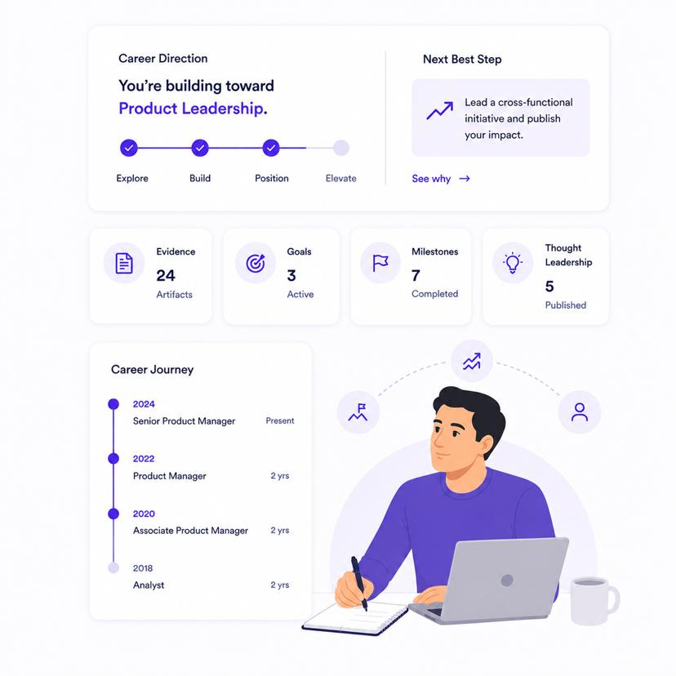
8. Proof-of-Work Portfolio Generator
Turn real projects into portfolio case studies containing the problem, the user's contribution, tools used, process, and measurable results. Generate shareable portfolio pages alongside the CV.
Why it's valuable: Especially useful for developers, designers, product managers, consultants, and career changers.
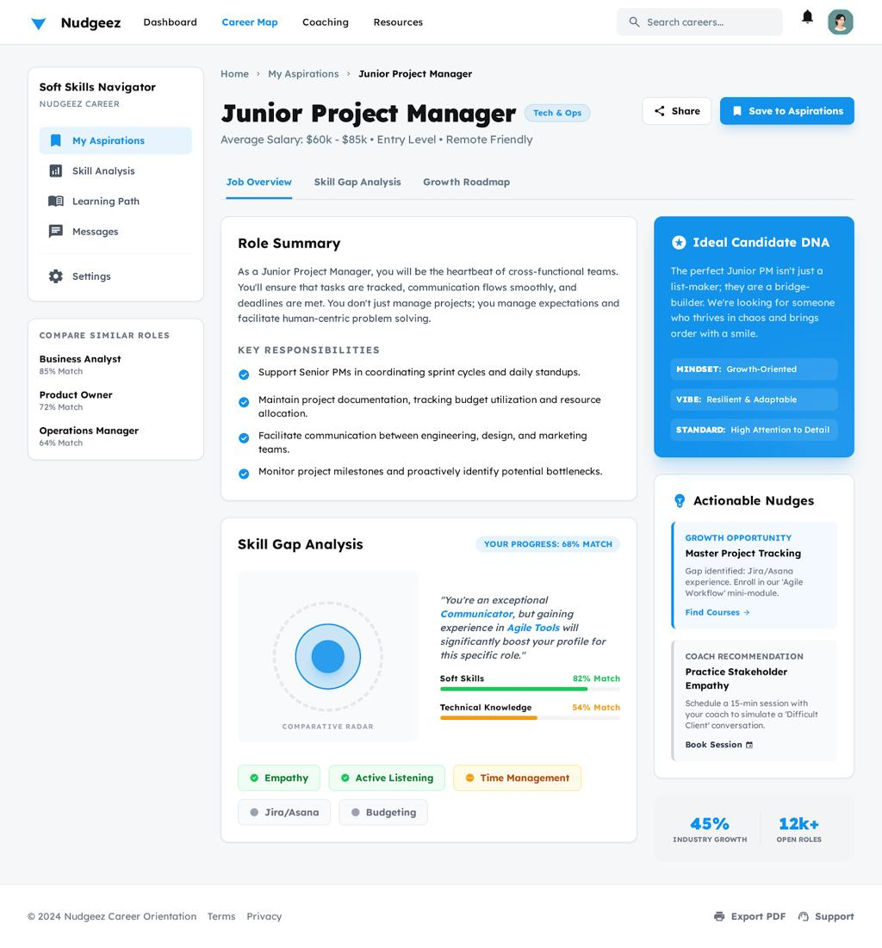
9. Career Switch Translator
Help users translate experience from one profession into language relevant to another.
For example, a teacher moving into project management may have relevant experience in planning, stakeholder communication, scheduling, and coordinating activities.
The AI identifies transferable skills only when supported by the user's actual experience and asks follow-up questions where evidence is missing.
Why it's valuable: It opens your product to career changers, return-to-work candidates, and people entering a new industry.
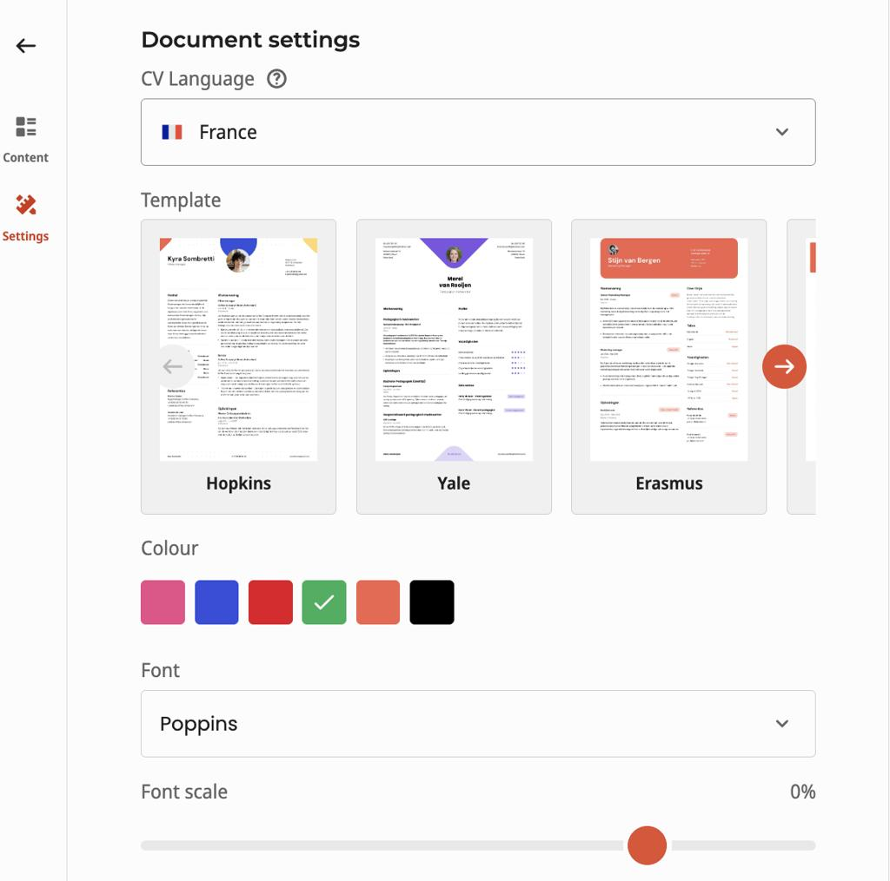
10. Global CV Localization Engine
Adapt a CV to a target country's hiring conventions and language, rather than simply translating the text.
- Country-specific CV conventions
- Local spelling and terminology
- Appropriate date, address, and contact formats
- Language-specific proofreading
- Regional guidance about what personal details to include or omit
Why it's valuable: Particularly relevant for people applying internationally. Keep country guidance current and avoid assuming every employer follows the same convention.
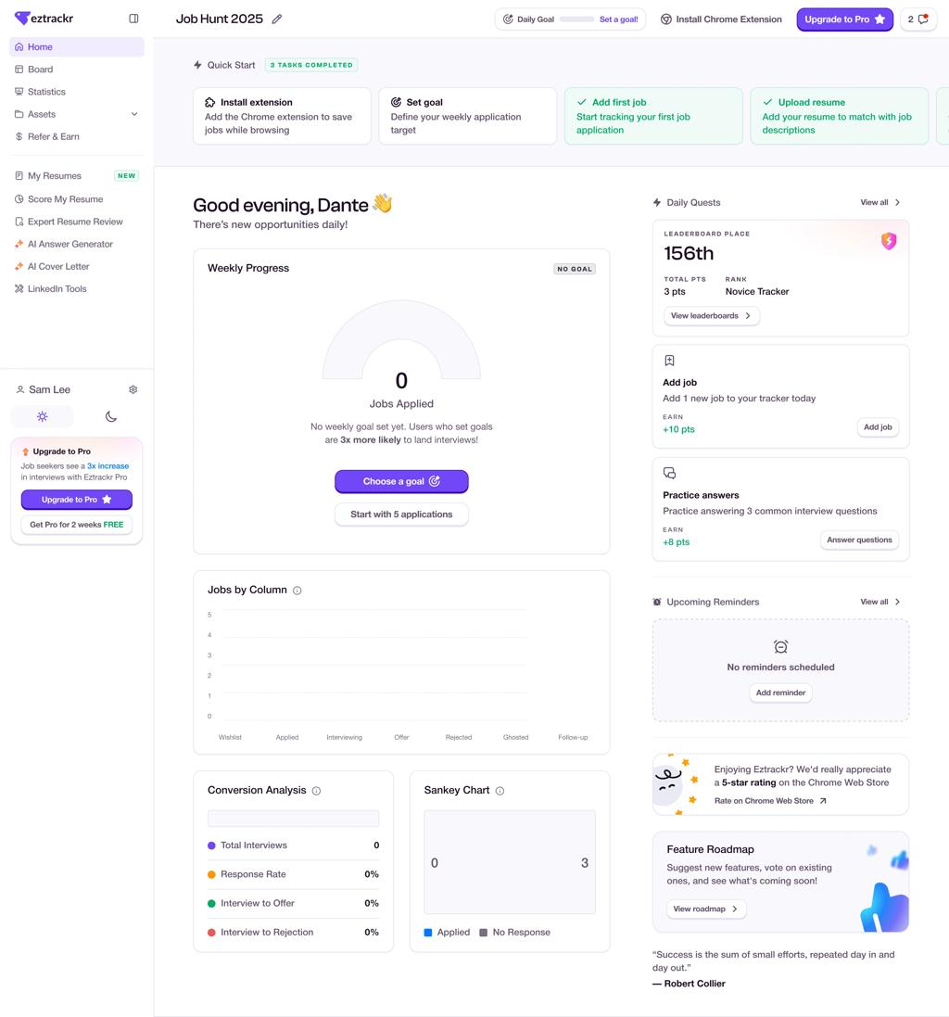
11. Personal Career Agent
Give each user an AI agent that understands their master CV, preferred roles, experience, location preferences, and salary expectations.
It can help evaluate job descriptions, recommend which opportunities to prioritize, prepare application materials, and identify skill gaps.
Later, you could add authorized job-board integrations and application assistance, with user approval before submitting any application.
Why it's valuable: It transforms your platform from a document editor into a recurring career assistant.

3. Features most CV builders don't combine well
The strongest product opportunity may be the workflow between features, not any single AI capability.
Here are three ideas I'd prioritize after the core CV builder.
A. Application Outcome Learning Loop
Every application links to the CV version, job requirements, cover letter, and eventual outcome. Users can record whether they received a response or interview.
Over time, the platform can suggest evidence-based improvements based on their own application history, without claiming to know the employer's actual screening decision.
B. CV Truth & Consistency Checker
Detect contradictory dates, inconsistent job titles, unsupported metrics, duplicate claims, and skills mentioned without supporting evidence.
Users can review each flagged statement and approve or correct it before export.
This builds trust by making accuracy a product feature, not an afterthought.
C. Recruiter Perspective Simulator
Review a CV against a specific vacancy from multiple perspectives: recruiter, hiring manager, and role-specific evaluator.
Each perspective explains the strongest evidence, unclear claims, missing context, and suggested follow-up questions.
Make clear that this is simulated feedback, not a real recruiter's judgment or a prediction of hiring success.

4. Which features should you build first?
I wouldn't build all of these at once. Start with a focused product that gives users a reason to return every time they apply for a job.
Suggested development roadmap for your first release
Phase 1 — Core CV Builder
Launch MVP
Build the essential product.
- CV creation from a guided questionnaire
- Upload and parse existing CVs
- Editable master career profile
- Professional templates and live preview
- PDF and DOCX export
- AI writing and achievement improvement
Phase 2 — Job Application Intelligence
Differentiation
Give users a reason to choose you over template-only competitors.
- Job description matching
- One-click tailored CV
- ATS readability checks
- Cover letter generator
- Application tracker
- CV truth and consistency checker
Phase 3 — Career Growth Platform
Build recurring value and longer-term retention.
- AI interview coach
- Career switch translator
- Portfolio generator
- Skills gap roadmap
- Personal career agent
- Application outcome learning

5. How could you monetize it?
A freemium subscription model is worth testing. The key is to let users experience real value before asking them to pay.
Plan | Potential offering
Free | One CV, basic templates, limited AI assistance
Pro | Multiple CVs, job-specific tailoring, advanced templates, cover letters
Career Plus | Interview practice, career roadmap, portfolio, application insights
Career Coach | Higher AI limits, advanced coaching, multiple target roles and career profiles
Treat these as proposed tiers, not finalized pricing. Test willingness to pay before setting prices.
My recommendation: Keep basic CV creation accessible and monetize the ongoing job-search workflow: tailoring applications, interview practice, and career insights.

6. Your potential competitive advantage
Here's the product concept I'd build toward:

AI Career Copilot
One profile. Every opportunity. A smarter job search.
Build — Create a verified master CV and career profile.
Match — Understand how well the profile aligns with a vacancy.
Improve — Find gaps and strengthen evidence of achievements.
Apply — Generate tailored CVs and cover letters.
Prepare — Practice interview questions specific to the role.
Learn — Track applications and improve future attempts.
One important principle: protect users' personal data, give them control over uploaded CVs, and never fabricate qualifications or promise that a particular score guarantees an interview.

7. Let's prioritize your product idea
If I were choosing only three differentiating features for the first version, I'd choose:
- Job-specific CV tailoring — the main reason to use the platform repeatedly.
- Achievement Discovery Engine — helps users create stronger content even when they don't know how to write a CV.
- Application Outcome Learning Loop — creates a longer-term advantage as users build their own application history.

